2 EVS Placement Opportunities in the Czech Republic - Decko Nachod and Deck Ryknov – Working with a youth centre | 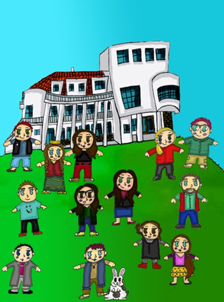
Project name: Decko Nachod or Decko Ryknov
Location: Czech Republic
Host Organization and web link: Decko Nacod
http://deckonachod.cz/ or https://www.facebook.com/Erasmus-with-Decko-1906690942890234/?fref=ts
Host Contact: Landline 00420-491 428 744/ cellphone reception 777694441
European Youth Portal Database Link: http://europa.eu/youth/volunteering/organisation/945427088_en
Sending Organization: UNA Exchange – www.unaexchange.org / evscoordinator@unaexchange.org
Dates: ASAP – 31st August 2017

Host Organisation Description:
The main goal of the Déčko organisations is to create space for non formal education of children and youth and also to involve the whole community by including the spirit of different cultures. There are around 90 hobby groups suitable for children and youth from 5 to 18 years and for more than 50 parents. Groups aim at different styles of dancing, painting, music, pottery, art-craft activity, climbing, hiking, cycling, canoeing and other wide range of non-formal activities.
They are also a leading regional organiser of summer camps. They organise around 20 summer camps every year (for age groups 4-20 years) on a variety of topics topics (e.g. arts and crafts, English, dancing, outdoors activities).• Besides that Decko organise occasional and open events for the community, for example kite competitions, Halloween events, spring celebrations, winter games and so on. There are training courses and schooling with experts too. They take an active part in organising numerous cultural, sports and charity events, such as The Terry Fox Run, the charity exposition Children to Children and Valentine’s ball. •
Decko have also been actively involved in the annual student organised event "Prima sezóna" for the local community .• Déčko’s cooperation with schools and NGOs in our region is very important. Together they organise numerous competitions and sports events. We are prepared to host more than 31 competitions. They also provide the information for youth about youth projects in our region, different cultural and sports events, job offers for youth, language lessons and offers for social life.• The Roma community is closely involved in the regular activities in our ICM club and garden of SVČ Déčko Náchod. All the activities are open to Roma youth but more importantly they encourage them to spend their leisure time meaningfully.

Proposed activities/ Volunteer tasks:
For the position at the host has space for volunteers who will go to local schools and assist with English language classes, it’s a great opportunity to get to know a new culture first-hand. The children are of various ages and you will have each lesson with a English teacher who will make you feel comfortable, you would also be expected to lead English conversation sessions once a week for Mothers with children who are already pretty fluent at English and just wish to continue speaking the language.
At the youth centre there is an array of different opportunities for you to get involved with like sports activities, arts and crafts, cookery lessons with kids, caring for animals in the youth centres mini zoo and many other wonderful annual events. The location of the project is in the beautiful North of the Czech Republic surrounded by beautiful mountains and forests and a really close proximity with the Polish border giving you the great opportunity to explore two countries at the same time throughout your year here.
In your free time you have the opportunity to join a wide range of different clubs for free such as guitar lessons and hip hop dancing. On this placement you will be living in a flat located close to the youth centre with other volunteers for the same organization and this is a great chance to make friends for life and learn about different cultures and gain wonderful new experiences. On your project you will also receive weekly Czech language lessons with a Czech Language teacher. We would love to hear from you! If you are interested in this position please contacts us and check out our Facebook page!

Living environment: Accommodation, food and pocket money will be provided.
Volunteer profile: – 18-30 at time of application, UK resident before and after departure, valid passport for at least 1 year after end of activity.

How to apply:
- Please contact evs@concordiavolunteers.org.uk as soon as possible indicating the project you are interested in or call Francesco Bonini on 01273 422218 .

