EVS Placement in Germany - The Youth Community Heidehaus – Working with Disadvantaged Young People | 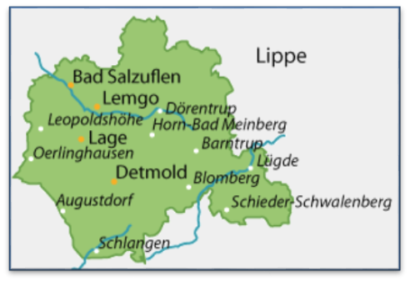
Project name: Jugendsiedlung Heidehaus
Location: Heidehaus, Germany
Host Organization and web link: Jugendsiedlung Heidehaus http://www.jgs-heidehaus.de/
Host Contact: Dachsweg 1, 32832 Augustdorf - Telephone: 05237-607 0/email: info@jgs-heidehaus.de Contact
Local coordinating organization and web link: IJGD http://www.ijgd.de/
Local coordinating contact: Telephone +49 228 22800-55/E-mail: ild.bonn@ijgd.de
European Youth Portal Database Link: http://europa.eu/youth/volunteering/organisation/930371621_en
Sending Organization: UNA Exchange – www.unaexchange.org / evscoordinator@unaexchange.org
Dates: ASAP – November 2017

Host Organisation Description: The Youth Community Heidehaus (Jugendsiedlung Heidehaus) offers a place for around 70 disadvantaged young people to live and gain an education and training in Heidehaus, a small community close to the town of Augustdorf. A team of 6-8 social-workers and trainers work in each of the eight groups which are located in eight different houses on the territory of Heidehaus. These groups are made up of between 6-11 youngsters (who are 13 to 21 years old).
The intensity of support provided depends on the individual needs of the young people. Some of them need nearly a one to one care and others less. The younger ones go to a school which is located within the community. The Youth Community Heidehaus also offers different job training opportunities (painter, bricklayer, gardener, cook, carpenter, housekeeper, office clerk) to the older youngsters living at Heidehaus who are around 16 years old. The main idea of the project Jugendsiedlung Heidehaus is to support young people to develop the ability to live independently, to become self-organized and an active part of the society they live in.

Proposed activities/ Volunteer tasks:
The volunteer will get the chance to support the youngsters and to deliver insight into their culture and their individual backgrounds. The volunteers are involved in daily life activities of the youth living at Heidehaus. They’ll support the children and youth in activities, such as preparing and having meals, keeping the house clean, washing clothes, doing homework, following up leisure activities etc.
Also, volunteers will work closely with a social work team and in every shift he or she will be guided by a trained staff member. Volunteers will also get an opportunity to accompany teenagers to various appointments as doctor, dentist, psychologist or appointments regarding schooling matters.

Living environment:
The volunteers will share a little house at the Heidehaus community in a calm neighbourhood. It is completely furnished, with a kitchen, bathroom and laundry facilities in the basement available to the volunteers and each volunteer has a separate single-bedroom. Food will be provided whilst volunteers are working and they will eat together with social workers and teenagers of the group. Heidehaus is situated in the forest next to unique sand dunes, popular hiking routes and around 4 kilometres from the little town of Augustdorf. There is a shuttle several times a day between Augustdorf and Heidehaus. Still it's useful when volunteers have a driver's license so they can borrow a car in the evening or the weekend in order to go to local places such as Detmold or even Bielefeld.
Volunteers will also get pocket money each month.
Volunteer profile: – 18-30 at time of application, UK resident before and after departure, valid passport for at least 1 year after end of activity.
This opportunity is only available to those who are able to travel to Germany without a VISA.

How to apply:
- Please fill out this application form and send it to ild.bonn@ijgd.de

