EVS Placement in Germany– INVIA – Working with children in a Montessori School | 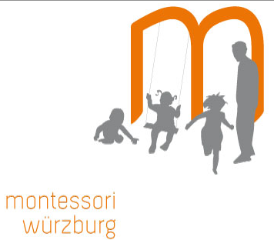

Project name: Montessori School
Location: Würzburg, Germany
Host Organization and web link: http://www.montessori-wuerzburg.de/
Host Contact: sekretariat@montessori-wuerzburg.de/
Local coordinating organization and web link: INVIA Würzburg, Franziskanergasse 3 ,97070 Würzburg, Germany
Local coordinating contact: manuela.dillenz@caritas-wuerzburg.de ; manuela.dillenz@jubi-unterfranken.de
European Youth Portal Database Link: http://europa.eu/youth/volunteering/organisation/933772150_en
Sending Organization: UNA Exchange – www.unaexchange.org / evscoordinator@unaexchange.org
Dates: ASAP - 08.09.17 (11 or 12 month)

Host Organisation Description:
The Montessori Würzburg was founded in 1991 by a parent initaitve. It is recognized as a non-profit sponsoring association which since 1997/1998 has been cooperating with the Christophporus school in Wuerzburg, a school for "life skills". This beneficial community wants to support and cultivate the school and pre-school pedagogical work grounded by Maria Montessori. The main concern of the Montessori school is the integration of children with disabilities. "The way, in Which the weak ones strengthen Themselves, is the same way, in Which the strong ones improve Themselves." (Maria Montessori). Twelve children from an external school are placed in different classrooms of the Montessori. The subjects are taught to all the children together, by the team of special pedagogues from the Christophorus school and teachers from the Montessori school.

Proposed activities/ Volunteer tasks:
In this school are children between 6 and 18 years. The children and youngsters work mainly in the form of a free-activity, which means that they chose different materials and try to make up with then various tasks and things. The volunteer will support the teachers and children and have the chance to get to know the materials and pedagogy of the Montessori school, she/ he can practice different things and exercises with a single child or with a small group.
The volunteer will also have enough free room to develop and offer their own ideas and projects. They will also be especially supported by the language teacher as it is seen as an opportunity to increase children’s interests in language and improve their foreign language skills
Some of the activities which were run by volunteers include cooking and baking workshops with dishes from volunteers ‘home, plays and theater in English and French, making music with the pupils, teaching traditional dances from the home countries of volunteers, conversation workshops in English and in French, and accompanying small groups of children during school- exchanges in Europe.
Volunteer profile: – 18-30 at time of application, UK resident before and after departure, valid passport for at least 1 year after end of activity.

How to apply:
- Please send a CV and Motivational Letter to Manuela Dillenz at manuela.dillenz@caritas-wuerzburg.de

