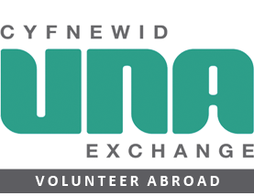
UNA Exchange staffing model
February 2019

