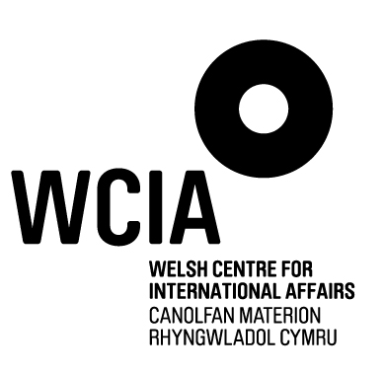
Hidden Histories
Recording Consent Form

Participant Name: ________________________________ Date of Birth: ________________
Project Title: ________________________________________
Recording Date: ________________________________
Thank you for agreeing to be recorded, to share your stories and experiences with _____________ and the wider community, or as part of a public event. As part of this participation, we would be grateful if you could give permission to use your recording, and any photographs we have taken / you have given us in connection with your recording, in any of the following ways, now or in the future:
- On the World Wide Web and through social media
- As a lasting resource in archives
- In exhibitions and displays in venues around the community
- In leaflets and publications
- On radio
- In learning materials, such as for use in the classroom and in examinations
- In drama productions
- As material in public lectures
Please indicate your agreement, including assigning the copyright of the photographs and recordings to WCIA, by signing below.
If you are below 16 years of age, please also ask your parent/guardian to sign below to authorise their consent.
Your Name (capitals) ____________________ Signature ______________________
Guardian’s Name ______________________ Signature ______________________
Address ___________________________________________________________
___________________________________________________________
Telephone Number ______________________ Email ___________________________
Date ______________________
Interviewer Signature _____________________

WCIA, Temple of Peace, Cathays Park, Cardiff, CF10 3AP

