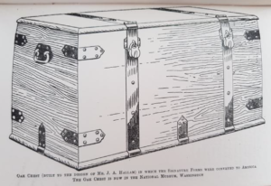
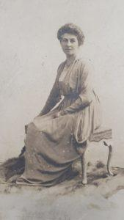
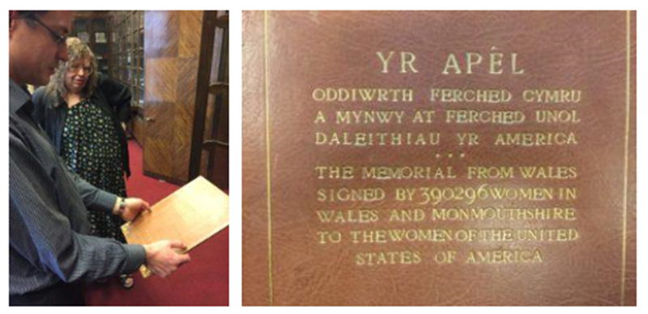
Name when Born: ______________________________
Year of birth: ______________________________
Place of Birth: ______________________________
In 1898 married: ______________________________
Name of son: ______________________________
Thomas’ birth/death: ______________________________
Extra facts: ______________________________
24th Oct 1916 married ______________________________
What was founded 1922? ______________________________
What happened in 1923? ______________________________
What were the names of the other two women who joined the ‘peace delegation?
____________________ ____________________
How many women signed the petition for America to join the League of Nations?
________________________ about ___% of Welsh women at the time.
Who found this? And where?
____________________________
____________________________
What is it?
_____________________________
_____________________________
What is it?
_____________________________
_____________________________

Websites I used…
https://www.wcia.org.uk/wcia-news/wcia-history/inspired-by-annie-the-story-of-the-1924-welsh-womens-peace-petition-to-america/

I can research Mrs Annie Griffith Hughes

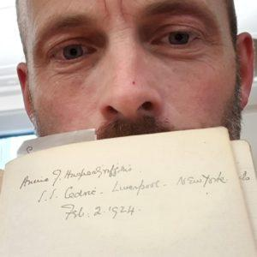
Who is in the picture? ______________________________
What did he find? ______________________________
When did he find it? ______________________________
Where did he find it? ______________________________
Extra facts ______________________________

What did these people do?
__________________________________________________________________________________________________________________________________

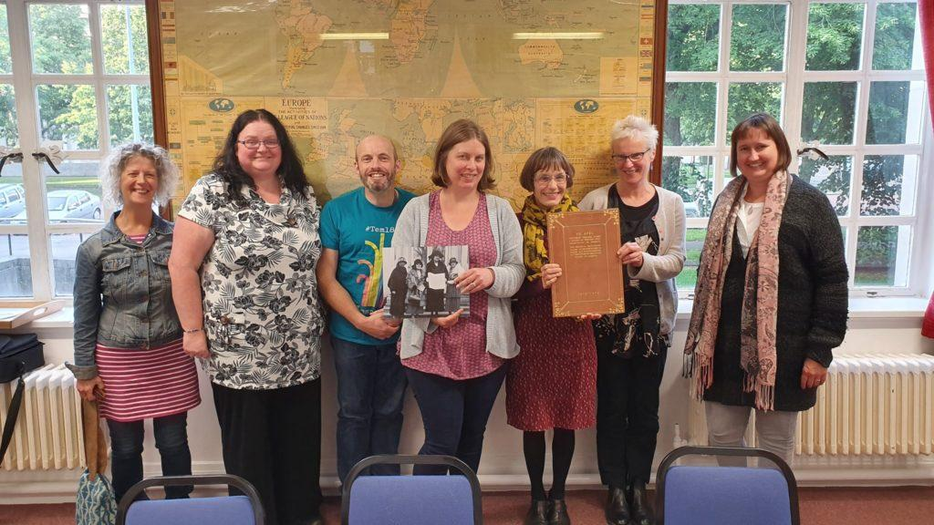
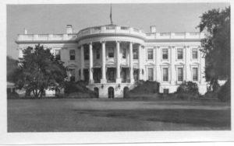
The Peace Tour of United States of America
She left the UK on : ____________________ Returned on ___________
On February 21st 1924 Annie met with president:
__________________________________
in Washington DC.
Other places Annie travelled to…
1. ______________ Notes from there ___________________________
_________________________________________________________
2. ______________ Notes from there ___________________________
_________________________________________________________
3. ______________ Notes from there ___________________________
_________________________________________________________
4. ______________ Notes from there ___________________________
_________________________________________________________

Where are the signatures and the chest now?
________________________________________________________

