I can estimate and calculate distance using scale (Spicy)

You will need an atlas, string and a ruler.
- Estimate the distance in cm
- Use the string to measure the distance between two locations.
- Use the ruler to measure the length of the string’s distance.
- Use the scale shown to convert to Km travelled.

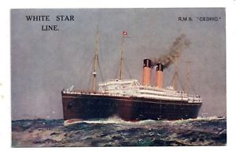 | Estimate  (cm) | Cm | Approximate Km
New York to Washington
Washington to Chicago
Chicago to Salt Lake City
Salt Lake City to San Francisco
San Francisco to Los Angeles
Los Angeles to Grand Canyon
Grand Canyon to Chicago

Chicago to Niagra Falls
Niagra Falls to New York

I can estimate and calculate distance using scale (Mild)

You will need an atlas, string and a ruler.
- Estimate the distance in cm
- Use the string to measure the distance between two locations.
- Use the ruler to measure the length of the string’s distance.
- Use the table to help convert to Km travelled.

 | Estimate  (cm) | Cm | Approximate Km | 1cm = 400 Km  2cm = 800 Km  3cm = 1200 Km  4cm = 1600 Km  5cm = 2000 Km  6cm = 2400 Km  7 cm = 2800 Km  8 cm = 3200 Km  9 cm = 3600 Km  10 cm = 4000 Km
New York to Washington
Washington to Chicago
Chicago to Salt Lake City
Salt Lake City to San Francisco
San Francisco to Los Angeles
Los Angeles to Grand Canyon
Grand Canyon to Chicago

Chicago to Niagra Falls
Niagra Falls to New York

