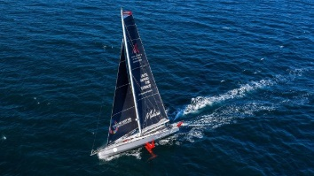
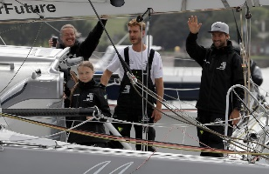
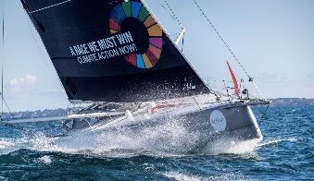
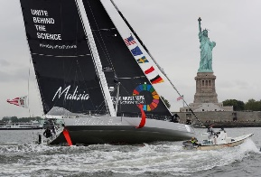
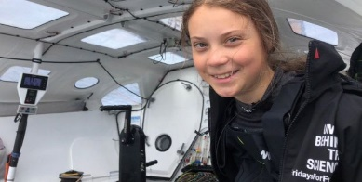
Greta Thurnberg travelled to the UN Summit in America in a 60ft Solar powered yacht. The main two sails were two different shaped and sized triangles.

Research the different types of triangles.
Equilateral Right angled Isosceles Scalene

When you have written your notes—Create a song/rap to help you remember the features of the different triangles.

Greta Thurnberg travelled to the UN Summit in America in a 60ft Solar powered yacht. The main two sails were two different shaped and sized triangles.

Research the different types of triangles.
Equilateral Right angled Isosceles Scalene

When you have written your notes—Create a song/rap to help you remember the features of the different triangles.

