I can sort and organise dates into chronological order.
Cut out and arrange on the timeline in chronological order.
By researching, add 3 move events onto the timeline of your own choosing.
Can you find out more about one of the events and explain your findings to the class.
January 1918
President Woodrow Wilson
asks that all nations work
together.
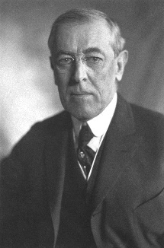

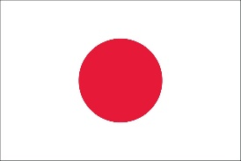
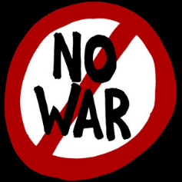

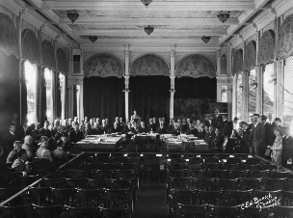



September 1921
The Permanent court of
International Justice is set up

March 1933
Japan leaves the League.
In October Germany follows.

September 1931
League of nations decide on
a convention to improve the
means of preventing war,
May 1927
International Economic
Conference
January 1920
The League of Nations
is set up after the
Treaty of Versailles.

February 1925
International Health
Conference, Singapore

September 1922
Number of non-permanent members increases from 4 countries to 6.

September 1930
First enquiry for creating
the European Union.

September 1926
Germany joins the League
of nations, non-permanent
members increases to 9.

