What is a Hustings?

A hustings is a meeting between people standing for election and the people who will be choosing whether or not to vote for them. For the candidates, it’s a chance to answer questions and endear yourself to your voters. For the voters, it’s a chance to find out more about what these people want to do about the issues that matter. This handout is a step-by-step guide to carry out your own Hustings. We will be covering all of this in an online training, this booklet is here to provide you with tools and structures to support you in planning the event. Please note this is here for you to use as far as it is useful. Don’t use what isn’t relevant!

Before the Event- First Steps

1.The first step is choosing your venue. To do this, you’ll need a rough idea of details like, who is coming, how many people are you inviting. If you’re working with others, it can be really helpful to talk through what you imagine the event looking like before you start researching so you know what you’re looking for. It will also help if you’re booking something because you’ll have a clear idea of what you want them to offer you. When you book your event, it can be useful to do a Risk Assessment to make sure it’s safe, and to consider whether you want to take photographs in the room. You can find sample risk assessment and consent below:

Here are some other questions you can think about:
Will you need microphones and a sound system?
Will you need wifi connection?
How much money do you have to spend?
Who do you want to come? Will they have requirements (access or prayer rooms for example)
What are the transport links like at that venue – will people need parking spaces, is it walkable from a train
What equipment or furniture will you need and where will you get it from? (tables, chairs, whiteboards, flipcharts etc)

The table below is here to help with the details that you might want to consider:

Venue name | How many people can come? | How much cost? | Wifi /speakers? | Parking/transport links? | Translation

Example 1 – photo consent form
📸 Photography & Video Recording Notice – Consent Statement
Please note that photography and video recording will take place during this Hustings event for the purposes of documentation, promotion, and public transparency. (you might want to change this bit)
By attending this event, you consent to being photographed and/or recorded. These materials may be used by the organisers and affiliated partners in printed and digital publicity, including websites, social media, and press releases.
If you do not wish to be photographed or filmed, please inform a member of the event staff upon arrival so we can accommodate your request wherever possible.
We appreciate your cooperation.

Example 2 – Risk Assessment
RISK ASSESMENT: Hustings for Scouts 2/7/25

We accept and embrace our duty to produce site specific risk assessments and safety systems of work. All assessments will be produced by competent persons.

Our risk assessment formats are consistent with the HSE Guidance ‘5 Steps to Risk Assessment’:

- Identify hazards
- Identify who might be affected and how
- Evaluate risk and identify/implement control measures
- Record
- Review

A basic risk assessment template is shown on the following page. It’s a good idea to walk around your venue so you can see anything that might come up and write it in your table.

TASK/SITE SPECIFIC RISK ASSESSMENT – HAZARD ANALYSIS
S = Severity |  |  | L = Likelihood of Happening |  |  |  | RR = Risk Ratings
1 = Insignificant – no injury |  |  | 1 = Very Unlikely |  |  |  | 0 - 4 = Acceptable
2 = Minor – first aid injury |  |  | 2 = Unlikely but possible |  |  |  | 5 – 9 = Adequate
3 = Moderate – up to 3 days off work |  |  | 3 = Fairly Likely |  |  |  | 10 - 16 = Tolerable
4 = Major Injury – over 3 days off work |  |  | 4 = Likely |  |  |  | 17 - 25 = Unacceptable
5 = Catastrophic - Death |  |  | 5 = Very Likely
List Hazards Here | Who may be harmed and how | S x |  | L = | RR | List existing control measures |  | Additional actions to further reduce risk | S x | L = | RR

The venue is located on a busy road | Adults and students attending | 2 | 3 | 6 | Adults and students to pay attention to road safety procedures and use agreed crossing points | XXX to advise teachers and students on safe passage – as well as noting safe drop off and pick up locations. | 1 | 2 | 2
Stranger danger | Adults and students attending | 3 | 2 | 6 | Sign in sheet for teachers and students. Ian on Reception to guard against strangers. Check DBS status of Adults. Any adults without DBS check not to be alone with children without supervision of adults with DBS check. | xXx have a list of adults attending | 2 | 1 | 2
Travel in to the temple may become difficult/dangerous | Adults and students attending | 5 | 1 | 5 | Teachers and students to make a value judgement based on road conditions. Coach companies reputable | Strong lines of communication where possible to ensure all travel issues are reported and discussed | 3 | 1 | 3
Students/adults may get lost on their way to or in venue | Adults and students attending | 1 | 2 | 2 | XXX to gather contact detail for local guest houses and hotels | Participants to also keep in touch (especially with XXX) and agree decisions accordingly | 1 | 1 | 1
Possibility of food poisoning or allergies | Adults and students attending | 2 | 3 | 6 | Participants to discuss allergies and ensure that catering is 100% compliant with food standards | First aider on site at all times and emergency response (999) and hospital numbers to hand | 1 | 1 | 1
Adverse weather | Adults and students attending | 3 | 2 | 6 | Check weather forecast before hand and on the day and pay attention to conditions. | If very hot weather, ensure enough water available for all participants throughout day. If stormy / windy weather, all activities held indoors. | 1 | 1 | 1

Assessment Date : | Review Date: | Signature:
Assessor Name: | Position: | Signature:

Who is coming
Who are your local Members of Senedd and how to get them interested in your event?

There are a few things that you’ll need to know when you organise your speakers. An important rule is that you have to make sure that you have invited someone from each of the parties running. Use this page to track which parties you’ve contacted and when. You might need to contact the parties more than once to get a response!

When you ask, it would be helpful to mention this will be a Hustings aimed at young people. Later in the process, they might also ask you to send them a few questions that will be asked so their candidate can properly prepare. You might also find this website useful for information about your local area

Name | Email | Phone number | Date contacted | Response
Welsh Labour |  | 029 2087 7700
Welsh Conservatives | Contact | The Welsh Conservative Party | 029 2073 6562
Plaid Cymru | Contact - The Party of Wales | 029 2047 2272
Green Party | Contact Us - Green Party | 020 3691 9400
Reform | Contact - Reform UK Bangor Aberconwy
Liberal Democrats | Contact Us - Welsh Liberal Democrats - Democratiaid Rhyddfrydol Cymru | 029 2031 3400

When you ask, it would be helpful to mention this will be a Hustings aimed at young people. Later in the process, they might also ask you to send them a few questions that will be asked so their candidate can properly prepare. You might also find this website useful for information about your local area

You will also be able to consider which other people you want coming to your event once the details are pinned down.

Choosing when you want to hold your event

Choosing the time for your event usually involves a lot of speaking to people. To make it as accessible as possible, it’s a good idea to:

Find out the best time to get MSs together
The time that most suits people in your local area to come
The time when you can get a venue to host it
The time when you can get your volunteers together to run the event

You can do this using a doodlepoll or over emails. Alternatively, you can speak to people directly and record it, or if you’re working with others, you can make a spreadsheet so you can compare your options. It’s helpful to know that, whichever time you choose, there will always be someone who can’t come, but the aim is to get the most people and capture anything that happens in some way.

Example 3 – Invitation Email
Dear xXx
In the run up to the elections in xXx, we want to make sure that everyone feels engaged with the democratic process in Wales. With more than xXx new voters in our (local area of xXx) this year, we want to give young people a chance to speak to their local MSs about issues that matter most to them by holding a Hustings with our local members of Senedd.
As one of the representatives for (local area), we would like to work with you to put together a Hustings in the town of xXx where we will look at topics including xXx and xXx. At this stage, we are aiming to hold the event in early xXx or late xXx. Can you please let us know which times you would be available to work with us and what you would need from us.
Yours faithfully
xXx

Before the Event- Next Steps
Congratulations! You now have all the information in place to hold your Hustings. This includes knowing who is coming (in terms of MSs) , when and where the Hustings will take place, and who you want to invite. The next steps for you will include planning your programme, pinning down who does what on the day and promoting your event to your local community.
Planning your programme
- Planning a programme to share with your participants

Now you know where and when your event is happening, it’s a good idea to start pinning down the details of what will happen during the session. For example,

do you want to some time for people to settle in or a tight timeline.

Will you have some questions agreed in advance with the MSs?

These might be:

- What will you do to improve Wales’s sustainability?
- How will you work with young people to improve opportunities for employment?
- What initiatives will you create to support mental health in Wales?
- What are your plans for reducing the impact of the cost-of-living crisis in Wales?
- Do you want opening speeches and if so, who will be making them?

You might have some of your facilitators doing welcome speeches or you might want to give the MSs a chance to introduce themselves and their main policies before we get started on the questions The programme below can be edited (heavily should you want it to be!) to include details that suit your event
Example 4 – programme

Hustings
Date and place of event
This version is also bilingual with welsh on one side and English on the other

Programme for the day
9.30am Registration and refreshments.
10.00am Welcome speeches
10 30am Questions to delegates
11:00 Break
11:10 Questions by delegates
11.30am Final discussions
11.50 am Monitoring and feedback
12.50pm Event Closes

Rhaglen Y Dydd
9.30am Cofrestru a Dirprwywyr i fod yn eu seddau
10:00am Iaith Croeso
10.30am cwestiynau I ddirprwywyr
11:00am Amswer egwyl
11:10am cwestiynau I ddirprwywyr
11:30am Trafod penderfyniadau
11.50am monitor a adborth
12.50pm Gorffen

Example 5 – Storyboard
Pinning down who does what
Now you have a very clear idea of what the day will involve, you can start to think about what you will need to do to ensure the event runs smoothly, including
- who will set up the furniture for the event,
- when they can get into the room,
- who will greet people
- who will host the Hustings
In all events, the devil is in the details so it’s good to be as clear as possible on what will happen during the Hustings, and to have at least one other person on hand to manage issues like health and safety (someone falls over), troubleshooting (someone spills a drink, the microphones don’t work) or safeguarding (someone behaves badly).
The aim with a storyboard is to give you a framework to cover absolutely every aspect of your event so nothing that happens during it will be a surprise!
Please note storyboards can vary a great deal in terms of how much detail is included. Please only include details that help you and ignore anything you don’t think you’ll need.
Storyboard example for Hustings 2025-26
Organisers
Name | Contact  (if appropriate) | Responsible for
 |  | Greeting
 |  | hosting
 |  | First aid
 |  | Safeguarding
 |  | Venue and set up

Timeline
When | What happens | Who
 | Lay out tables at front of stage with water and microphones
 | Test microphones
 | Set up register for people who have said they would come
 | Lay out xXx chairs
 | Check refreshments have arrived / all vegetarian / labelled
 | Make sure speakers are ready for the welcome

Housekeeping –

emergency procedures

Mobile phone usage & behaviour

Importance of timekeeping

Reminder to take care of valuables / not leave unattended

Participate / ask questions

Child protection focal Point

Photographer and press

Comfort breaks / location of toilets

Photographer

 | Welcome – Agenda

Example 6 – Promoting your event
- Promoting your event and getting a sense of who is coming

When it comes to promoting, you will no doubt have spoken to people about what you’re doing. The key with promoting will be in thinking about people who might not know about it Consider:

- How to get a wide range of people interested in your event (social media, emails, contacting local schools or other community groups, that might include young members of the political parties)
- How to work with other groups in your Scouting community to promote each other
- Whether you have anyone in the community who might help you get the word out

One other thing you might want to consider is whether you want to sign people up. Platforms like Eventbrite and tickettailor are free for free events and you can track your participants, or you might want to have a system where your participants email somewhere to let you know they’re coming. You would only need to do this if you are expecting large numbers of people but it can be helpful to know. Those platforms also have a page where you can add things like photo consents if you want to take photographs so they can be helpful there too. In the booklet, you can look at example six to see what an example text might look like.

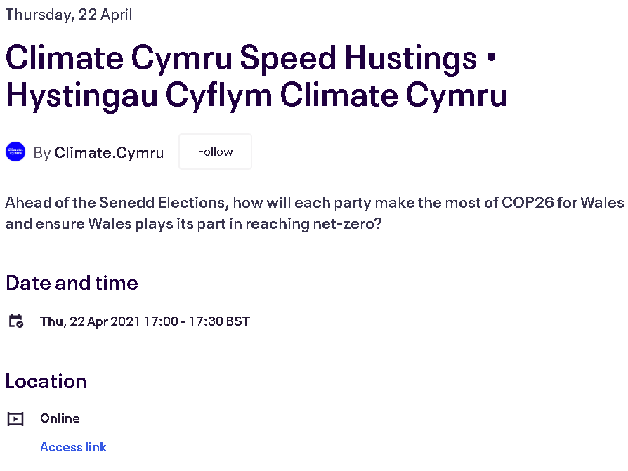
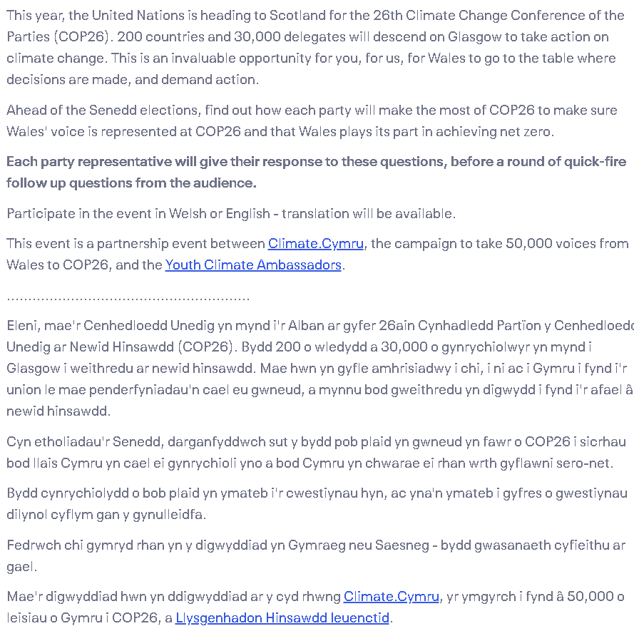


During the Event
You’ll be pleased to know that the vast majority of the work will have been done before the Hustings starts! However, on the day of the Hustings, there are a few top tips that we can share:
- Have all the information available

It is always as the event is starting that people want copies of storyboards and programmes so have plenty available . The clearer your roles and preparations are laid out, the easier it will be for your team to get things organised.

- Keep an eye on your email/phone

Communication is essential to everything running smoothly on the day so make sure that your participants have a way to contact you that works for everyone. It might be that you have to be careful with safeguarding measures so you’ll need an agreed point of contact that’s safeguarding friendly. Similarly, you and the other people running the Hustings will likely need some sort of easy way to speak if one of you is running late or managing a technical problem. Some solutions can be

- Having a whatsapp group with DBS checked adults can be a quick way around this but you can also
- Having an agreed event email address that an only be accessed by a certain number of people

- Expect things to go wrong or not run to time

Events always come with unexpected events so try to anticipate it and build it into your management of the event. For example, you will have some people arriving early and others arriving late so maybe make your arrival time more of a ten minute window. Or anticipate the technology not quite working and have a backup, and a person who can fix it if need be

Try to measure the impact of what you’re doing

With all events, there is something to be learned. Try to build something into the day where you find out about the impact the Hustings has had both for the people watching and the people speaking. You can also ask about how the event was run and what you could do differently next time.. To measure, you could use photos (although you’d need consent from participants), have a discussion and someone in the room collecting quotes, or if you know the participants well, you can use case studies. There are a few collected templates in the accompanying booklet

After the Event

You’re basking in the glow of your fantastic achievement and everyone has had the best time at your Hustings! Even though the event itself is done, there are a couple of top tips to round off the event in the best possible way.

- Make sure you thank and speak to everyone
All networks are built on relationships . Make sure you speak to as many people as you can at your event and make time to appreciate what they did to be there.
- Contact everyone who showed an interest in the event and “round it off”
There will be questions that people didn’t get a chance to ask. There will be questions that the MSs didn’t have a chance to answer. There will also be people who really wanted to go but couldn’t . For all of these people, an email that includes information about the day can make people feel they played a part in it.
- Follow up with anyone who spoke in particular
This is similar to point one but you may want to work with MSs again in particular so make sure you send them an email to thank them for their participation and ask what they will do with the info they gathered from the day
- Follow up on the learning
You may want to do another Hustings one day in the future. If you do, having all the info you used for this one stored makes it a much easier prospect so hang onto it!
Example 7 – Thank you for coming
Dear xXx
I wanted to write and offer my sincere thanks for coming along to our Hustings on xxx. The event gave us a real opportunity to find out more about the upcoming elections and your contribution made that possible.
Now that we are workig together on these issues, it would be great to stay in touch about other events. Do keep in touch with us on Xxx, xxx to hear our updates or tell us about yours
OR
We wanted to offer an opportunity to answer any questions that you didn’t have a chance to answer. We’d be more than happy to circulate your answers with our network.
Thanks again for coming along to work with us and if you’d like to get in touh again, our email isXxx @ xxx.org.uk

