Reynette Roberts MBE – building peace through welcome

Reynette Roberts is a Welsh humanitarian known for her work supporting people seeking sanctuary and for helping to build a culture of welcome in Wales.
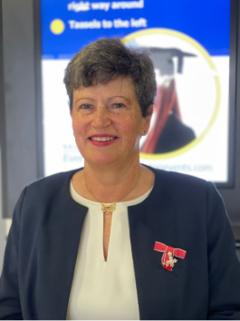

A vivid memory I have of Reynette encapsulates her leadership. At Oasis, a daily hot lunch is provided for asylum seekers and refugees. On one occasion, while staff were still busy with other tasks, Reynette—the CEO—was the first to leave her office and begin serving food. She did so quietly and without drawing attention to herself. The rest of the staff, including myself, were wrapped up in our work, forgetting this simple but crucial task: feeding those in need. It was a small but clear example of how she worked—stepping in where needed and focusing on people.

Her early experiences volunteering with displaced communities in Jordan, followed by a career in nursing, brought her into contact with people affected by conflict and forced migration. These experiences shaped her long-term commitment to working alongside refugees and asylum seekers in practical ways.

Founding Oasis
In 2008, she co-founded Oasis in Cardiff. It began as a small, informal space and grew into a well-established community organisation.

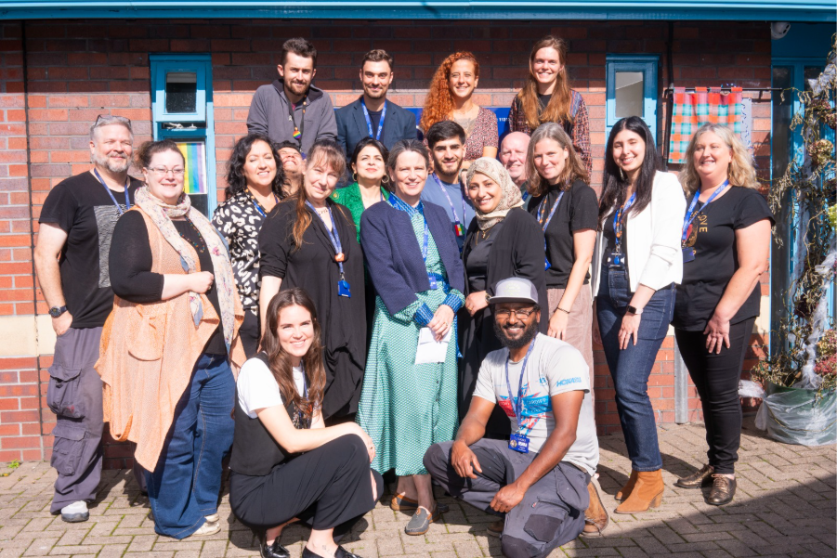
Oasis was set up to offer safety, support, and connection for asylum seekers and refugees rebuilding their lives in a new country.

Services and Community Impact
Under Reynette’s leadership, Oasis developed a wide range of services to meet both immediate needs and support longer-term integration. These include:

Practical support: hot meals, clothing, and basic supplies for people facing hardship, organised and served by staff, service users, and volunteers.

Advice and advocacy: help with housing, access to healthcare and understanding the asylum process.

English language learning: ESOL classes to support communication and independence, with a focus on participatory teaching methods that respond to the real needs of displaced people.

Skills and employability programmes: training, volunteering, and routes into work, with many former service users becoming volunteers and staff.

Wellbeing support: activities that support recovery from trauma, including creative and physical activities, as well as the establishment of Mind Spring—a psychoeducational course focused on mental health provision for people seeking sanctuary.

Community activities: shared meals, social groups and cultural events that help people connect.

Together, these services help people rebuild confidence, develop skills and form supportive networks.

Looking beyond the clearly defined services, Oasis has offered what it says on the tin: a real oasis for those who find themselves struggling in a new world—a place full of life, community, and compassion.

Nation of Sanctuary – Policy and Practice
In 2019, the Welsh Government introduced its Nation of Sanctuary plan, aiming to make Wales a place where refugees and asylum seekers are welcomed and supported to rebuild their lives.

The plan set out actions across areas such as housing, education, healthcare and employment. It also focused on building more inclusive communities and improving public understanding.
Reynette Roberts contributed to the wider conditions that made this policy possible and meaningful in practice by:

Providing a working model: Oasis demonstrated how community-based support could work in practice. Its approach—combining practical help, language learning, wellbeing support, and social connection—reflects many of the aims later set out in the Nation of Sanctuary plan.

Working in partnership: Oasis collaborated with local authorities, health services, and other organisations, helping to shape how support for refugees could be delivered at a local level, particularly in Cardiff.

Contributing to sector discussions: Through her leadership, Reynette was part of wider conversations across Wales about how to support people seeking sanctuary in ways that are practical, fair and sustainable.

Supporting culture change: Oasis created regular opportunities for local people and those seeking sanctuary to meet and build relationships, increasing understanding and support within the wider community.

While Nation of Sanctuary is a government policy, its impact depends on how it is carried out in practice. Work led by Reynette Roberts helped show how its principles could be put into action.

Leadership and Approach
As CEO for over 15 years, Reynette Roberts led Oasis from a small initiative to a recognised organisation. Her approach focused on inclusion and participation, ensuring that people with lived experience were involved in shaping services.
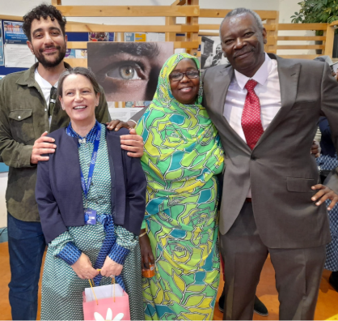

This work supported wider efforts to develop Cardiff as a City of Sanctuary, where communities and organisations actively welcome refugees and asylum seekers.

Recognition and Legacy
Reynette Roberts was awarded an MBE and made an Honorary Fellow at Cardiff University for her services to refugees and community cohesion. Her work has influenced both individual lives and wider approaches to support in Wales.

After stepping down in 2023, Oasis continues to provide support, opportunities, and community for people seeking sanctuary.



Reynette continues her service to society as a board member of Race Equality First. She is also a life coach and a refugee manager at Green Man Festival, where she works to bring asylum seekers and refugees to Brecon to volunteer and engage in the wider community.

Peacebuilding in Practice
This work reflects a practical form of peacebuilding. By creating spaces where people are supported, included, and able to take part in community life, Oasis—and Reynette’s current projects—contribute to stronger and more connected communities.

Her approach to practical compassion is echoed in the words of the Catalan poet Miquel Martí i Pol:

“La pau no és un cop de vent sobtat, sinó la pedra en la qual cada dia cal esculpir l’esforç de conquerir-la”

“Peace is not a sudden gust of wind, but the stone in which every day the effort to conquer it must be sculpted”

Words and books may guide us, but intentional action—moment by moment—is what contemporary peacemakers such as Reynette offer us.



Key Themes
Sanctuary and dignity
Practical, community-based support
Inclusion and participation
Policy shaped through local practice
Wales as a Nation of Sanctuary

Hyperlinks (for reference):
- Cardiff University honorary fellows page: https://www.cardiff.ac.uk/about/honorary-fellows

- Oasis – history: https://www.oasiscardiff.org/our-history-1⁠

- Oasis – news: https://www.oasiscardiff.org/news/news-from-oasis⁠

- Oasis – what we do: https://www.oasiscardiff.org/what-we-do

- Welsh Government – Nation of Sanctuary Plan https://www.gov.wales/sites/default/files/publications/2019-03/nation-of-sanctuary-refugee-and-asylum-seeker-plan_0.pdf

